Conductivity, Temperature, Depth Protocol
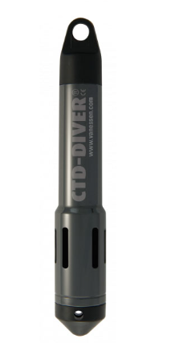

Van Essen CTD-Diver (model DI282)
Range: 0 - 120 mS/cm conductivity, -20 - 80 ℃ temperature, 0 - 50 m depth

Equipment and supplies needed:
- VanEssen CTD-Diver
- Zip-ties (or another method for fastening to sampling bottle)
- Computer with Windows 10 or 11 operating system, with Diver-Office software installed
- Diver-USB reading unit

Notes:
- The CTD-Diver should be attached to the Niskin bottle before the Niskin is deployed into the water column.
- To program the CTD-Diver settings before first usage, see the “Sensor Configuration and Data Transfer from Instruments” sheet.
- The instrument can record sampling rates of 1 second - 99 hours. 1 minute is recommended for the GEMs program.
- The on-board battery is not replaceable. For this reason we recommend being conservative about usage - i.e. program to start near the start time of the first sampling event of the mission, and stop the recorder sooner rather than later when the last event of the mission is captured, rather than waiting hours to stop it.
- Make sure the instrument is in “fixed record interval” mode before sampling so that measurements are collected at each fixed time interval and not averaged.
- Make sure the instrument is in “fixed length memory” mode before sampling so that data is not overwritten when the memory storage becomes full. The instrument's internal data memory can store up to 144,000 data points, however every time the CTD-Diver is initialized, the onboard memory is cleared, therefore care must be taken to download data after every sampling mission.
- If the CTD-Diver hasn’t been used for an extended period of time (> 20 days), soak the instrument in a dark bucket filled with deionized water or tap water for ~24 hours. Especially prior to a conductivity calibration, programmed to sample at a 1 minute interval.

Preparation Steps:
- Make sure the settings for the CTD-Diver are configured with a computer prior to taking the instrument for water sampling. See “Sensor Configuration and Data Transfer from Instruments” sheet.
- Program the diver using Van Essen’s Diver-Office software. Detailed in “Sensor Configuration and Data Transfer from Instruments” sheet.
- Logging can be initiated immediately, or programmed to start at a specified time.
- We recommend operating in UTC.
- The CTD-Diver should be attached to the Niskin bottle before the Niskin is deployed into the water column.

Complete Logging:
- When the sampling mission is complete, stop logging and download data as detailed in the “Sensor Configuration and Data Transfer from Instruments” sheet.
- Thoroughly rinse the sensor with deionized or the freshest water available. Should more rigorous cleaning be required, consult the Van Essen CTD-Diver Manual.
- Ensure the unit is stored with the end cap covering the optical data port on the CTD-Diver.

Calibration:
- The CTD-Diver is factory-calibrated.
- Only conductivity can be user-calibrated if there is access to standard solutions. The instrument must have the logging status stopped for calibration. Solutions with conductivity concentrations of 1.413 mS/cm, 5.000 mS/cm, 12.88 mS/cm, and 80.00 mS/cm can be used for calibration.
- The pressure reading should be checked periodically against a known pressure measurement (e.g. from regularly serviced weather stations). If there is a high degree of confidence that the sensor is still within calibration, the sensor may be used for obtaining atmospheric pressure values for the miniDOT calculation of % saturation. Should the pressure sensor drift it will still be able to be used for measuring the water column component of the pressure reading, as the atmospheric component of the reading is subtracted from the absolute reading by comparing the full reading to the reading of the sensor when it is just out of the water before and after deployment.

For Conductivity Calibration:
When the CTD-Diver has not been used for an extended period of time (weeks to months), take the following steps:
- Program the CTD-Diver with a 1 minute sample interval and start the CTD-Diver.
- Immerse the CTD-Diver in tap water for a period of at least 24 hours.
The conductivity sensor is, in contrast to the pressure and temperature sensor, sensitive to pollution, so check the sensor regularly. A simple verification consists of two steps.
- Take the CTD-Diver out of the water and shake it dry. Rinse with deionized water if there are any concerns about cleanliness. Connect the CTD-Diver to the computer and set it to measure in Specific Conductivity. Take a live reading in air; the reading should be 0 mS/cm. The reading may be slightly higher if the conductivity sensor is not completely dry. Do not touch near the conductivity cell with bare hands.
  - Immerse the CTD-Diver in a conductivity calibration solution. Ensure that there are no air bubbles trapped inside the conductivity measurement cell. Take another live reading and compare with the value of the calibration solution. Note: The solutions should have a temperature between 5 °C and 30 °C. If the unit was not programmed to log in Specific Conductivity, the readings should be corrected for temperature according to the Van Essen formula
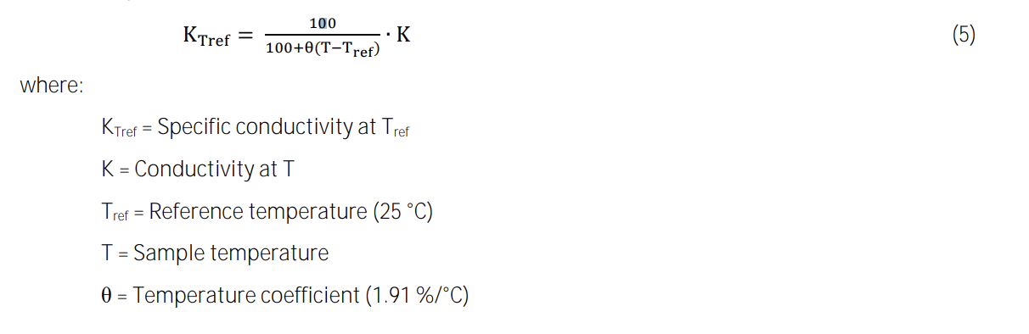
As a rule of thumb, conductivity varies by 2% for each 1 °C change in temperature.
  - If the deviation is greater than the specified accuracy, it is recommended to recalibrate the CTD-Diver. After Calibration ensure that the logging type is returned to Conductivity instead of Specific Conductivity.
Additional background on calibration:
The conductivity accuracy specification of the CTD-Diver for the full 0-120 mS/cm measurement range can only be achieved if the CTD-Diver is calibrated at all four calibration points (1.413, 5, 12.88, and 80 mS/cm). If calibrating to only two points, choose two that all measurement values will fall between, typically 12.88 mS/cm (which may be labeled as 12,880 µS/cm) and 80 mS/cm in seawater If the user calibration is later carried out at the four calibration points, then the CTD-Diver will once again meet its specifications for the full measurement range.
Prior to each reference measurement and/or calibration, the CTD-Diver must be thoroughly rinsed in deionized water. After it has been rinsed and shaken dry as much as possible, it should not be touched by bare hands since the reference liquid can easily become contaminated by residual contaminants and/or residual salts left on hands. This invalidates a reference measurement/calibration since the reference has become distorted. This is also why this calibration solution may never be used twice.
Calibration Steps:
- Calibration should take place at a stable temperature between 5 °C and 30 °C. Set out calibration fluids in a room within this temperature range to allow them to stabilize prior to attempting calibration.
- Connect the CTD-Diver to the computer and open the Diver-Office software. Click the “calibrate” button located in the Diver dialogue toolbar.
- Select the checkboxes next to each calibration solution that will be used. Click “Calibrate”.
- Immerse the CTD-Diver in the lowest-concentration solution and work to the highest concentration.
If the calibration fails, check to make sure the appropriate calibration solution is being used, that the CTD-Diver is connected securely to the Reading Unit, and that the Diver’s sensors are submerged in the solution. If calibration still does not work, restore the factory settings.
To view the calibration history while the Diver is connected to the reading unit, click the “calibration history” button on the Diver dialogue toolbar. Any significant changes in calibration over time can result in anomalies in measurement data.
Post-calibration:
This chemical is not considered hazardous and the used calibration solution can be discarded down the sink. It mostly consists of a mix of water Potassium Chloride (KCl) and small % (1-2%) of an alcohol. Tightly close the bottles of calibration solution and use parafilm to wrap around the lid/bottle seal to reduce evaporation. Opened bottles may be affected over time, so it’s best to open a new bottle if one has been sitting around for months.

